CENWP-OD-B 01 August 2023

MEMORANDUM FOR THE RECORD

SUBJECT: 23BON074 MFR WA Shore UMTJ RB1 Lamprey Mortality

On the morning of 01 August, Project Biologists discovered a Pacific Lamprey mortality in the UMTJ RB#1 (Upstream Migrant Tunnel Junction) of the WA Shore LPS system. The fish was scanned for PIT tags and returned to the river.

- Species – Pacific Lamprey (Entosphenus tridentatus)
- Origin – Unknown
- Length – Approximately 64.8 cm.
- Marks and tags – none
- Marks and Injuries found on carcass – none
- Cause and Time of Death –
- Future and Preventative Measures – none

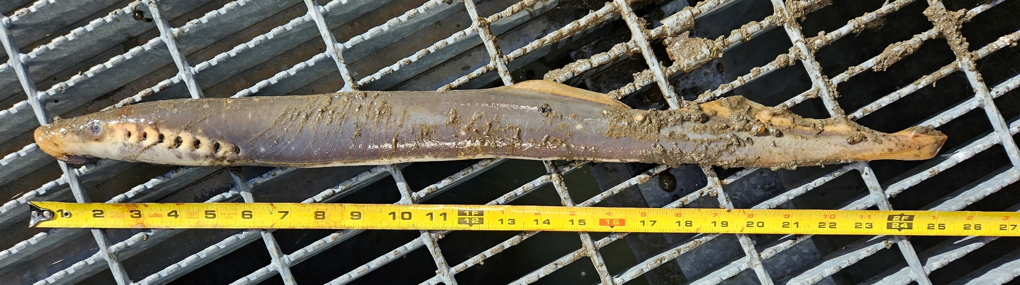

Sincerely,
Bonneville Project Fisheries

